Ocean Wings Trading Co.

CR. 2055025122 – C.O.C. 201067 – Capital 27,000,000.00 SAR

COMMERCIAL OFFER

RFQ NO. | Request for Quotation _ Filler Wire and Electrode | REF | OW-WLDG-RAK-0605
DATE | 02.11.2026 | REV | 00
COMPANY | BRANCH OF HYUNDAI ENG. & CONST. CO., LTD.
ATTENTION | Mr.
SUBJECT | Request for Quotation _ Filler Wire and Electrode

Dear Sir,

Thank you for the inquiry. Further to the said inquiry please find below the price for the requested Item.

SL  No | Description | Lead Time | QTY | UOM | Unit  Price SAR | Total  Amount SAR
1. | P/N 126024R150_OK TIGROD 12.60, AWS ER70S-3, SIZE  2.4MM Pkg 5kg/pkt | Ex stock | 500.00 | Kg | 17.80 | 8,900.00
2. | P/N 5550253AV0_OK 55.00 L, E7018-1 SIZE 2.5 × 350  mm, 3/4 VP | Ex stock | 500.00 | Kg | 17.80 | 8,900.00
3. | P/N 5550323AV0_OK 55.00 L E7018-1 SIZE 3.2x350mm 3/4 VP, | Ex stock | 500.00 | Kg | 17.75 | 8,875.00
4. | P/N 163016R150_OK Tigrod 16.30, AWS ER316L, SIZE  1.6MM Pkg 5kg/pkt | Ex stock | 500.00 | Kg | 90.00 | 45,000.00
5. | P/N 163024R150_OK Tigrod 16.30, AWS ER316L, SIZE  2.4MM Pkg 5kg/pkt | Ex stock | 500.00 | Kg | 80.95 | 40,475.00
6. | P/N 163024R150_OK Tigrod 16.30, AWS ER316L, SIZE  3.2MM Pkg 5kg/pkt | Ex stock | 500.00 | Kg | 80.95 | 40,475.00
7. | P/N 6398252030; OK 316L; AWS-E316L16 DIA 2.5 x 300  MM PKG 10.2 Kg/Box 1.7kg/pkt | Ex stock | 499.80 | Kg | 82.50 | 41,233.50
8. | P/N 6398323020; OK 316L ; AWS- E316L-16; Dia-  3.2x350mm; Pkg- 12.3 kg/box 4.1kg/pkt | Ex stock | 496.10 | Kg | 82.00 | 40,680.20

Terms and Conditions:

. Validity : 1 week
. Delivery : Prices are subjected to DDP Dammam/Jubail
TOTAL AMOUNT : 2,34,538.70
VAT @ 15% : 35,180.81
NET AMOUNT : 2,69,719.51

. Payment Terms
. Make
. Note
: As agreed terms
: ESAB
: Exclusive 15% Vat on above offer.

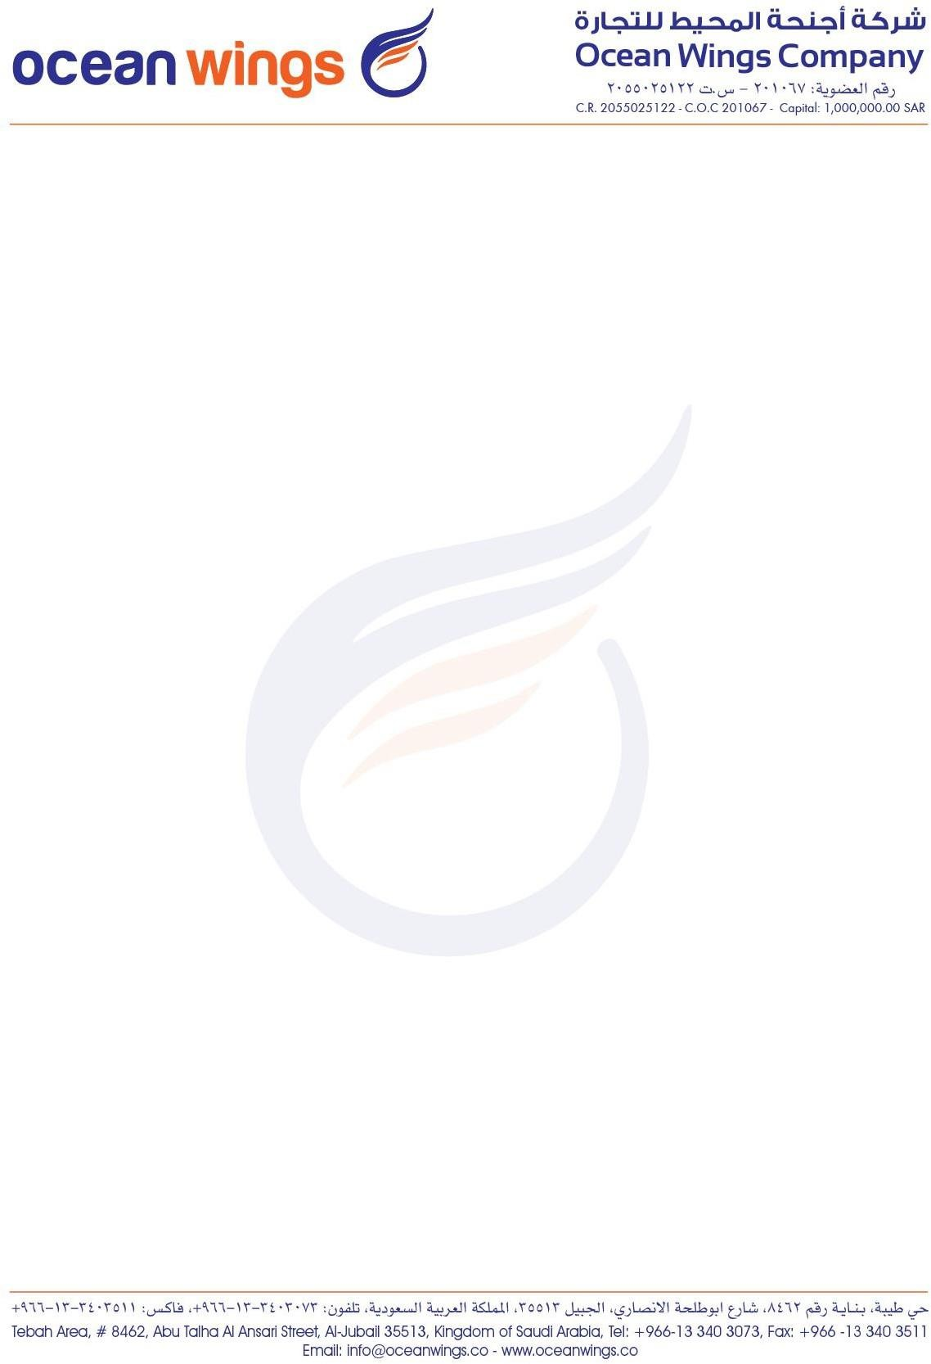






I hope the above offer is in line with your requirement and we look forward for your valued support.



Ocean Wings Trading Co.
CR. 2055025122 – C.O.C. 201067 – Capital 27,000,000.00 SAR

If you have any queries, please feel free to contact us.


Rameez Abdul Khadar
Sales Executive
Landline: +966 13 3871100 Ext: 991
Mobile: +966 559380672
Email: Rameez.k@oceanwings.co Website : www.oceanwings.co

AUTHORISED DISTRIBUTOR & STOCKIST

